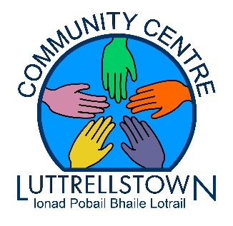

Join us for some FREE

~ Chakra Dancing for Seniors & Adults~
with
~Chakra Dancing Teacher Frances McDonnell~

Freestyle, suitable for all, no previous dance experience needed
please wear loose comfortable clothing

From April 26th on Wednesdays 13.30pm – 15.30pm

Enrolling now at
Luttrellstown Community Centre
Call 01 8179896 or drop into us

‘A Beautiful Workout for Mind, Body and Spirit’
