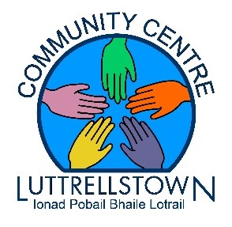

FREE YOGA
Classes for Seniors and Adults
We wold like to invite you to join us every Friday from
2.15pm-3.15pm
Starting Friday March 24th
For more information, & register Contact the centre at 01-8179896
Bringing our Seniors & Adult Community together for some slow and gentle Yoga stretches
The class is for Senior & Adult Beginners no experience needed
Never too old to reap the rewards of Yoga

Regular yoga practice creates mental clarity and calmness
Increases body awareness
Relives chronic stress
Relaxes the mind
