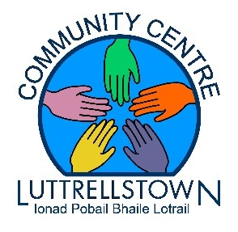

FREE YOGA
Classes for Seniors and Adults
We wold like to invite you to join us every Friday from
2.15pm-3.15pm
Starting Friday March 24th
For more information, & register Contact the centre at 01-8179896

Bringing our Seniors & Adult Community together for some light Yoga stretches

Regular yoga practice creates mental clarity and calmness
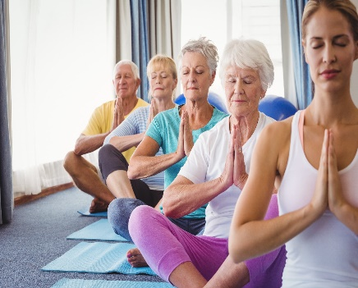
Increases body awareness
Relives chronic stress
Relaxes the mind

