Luttrellstown Community Centre is running a 16-week FREE Photography Course

~Starting Thursday, 26th of January~
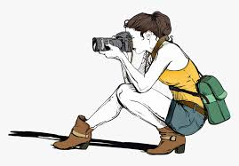
~11.30am-1.30pm~

‘No matter what type of camera you use, learn the fundamentals of photography so you can take great pictures.’
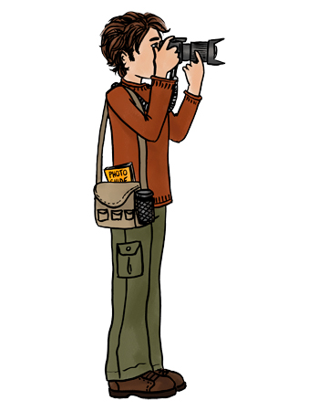
Places are limited
Please contact the Centre on 01-8179896 or email info@luttrellstowncommunitycentre.ie

