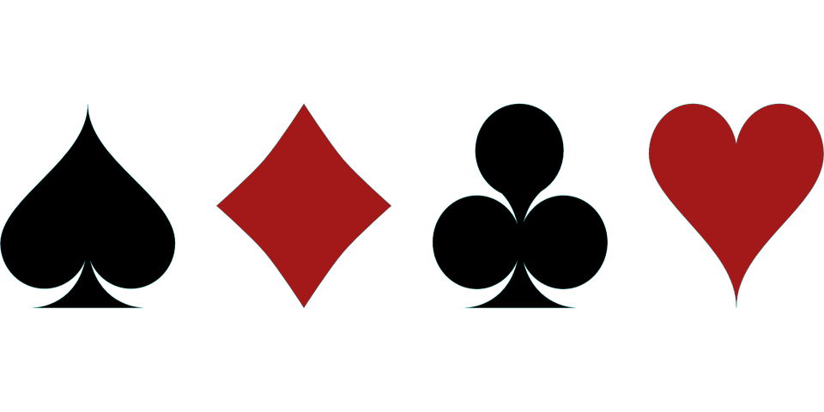 The Vue Bridge Club

Would you like to learn or play Bridge?
Bridge is a great way to meet new people, challenge your mind and enjoy either a morning, afternoon or evening with friends.

Where: Luttrellstown Community Centre.
Days:
Mondays from 7.00 P.M.TO 10.00 P.M
Fridays from 11.00 to 2.00

Classes for Beginners and Improvers.

Contact Yvonne at 0868592638 or
by e-mail to ymedalton@gmail.com
(Qualified CBAI Teacher)

New members always welcome.

