LUTTRELLSTOWN COMMUNITY CENTRE

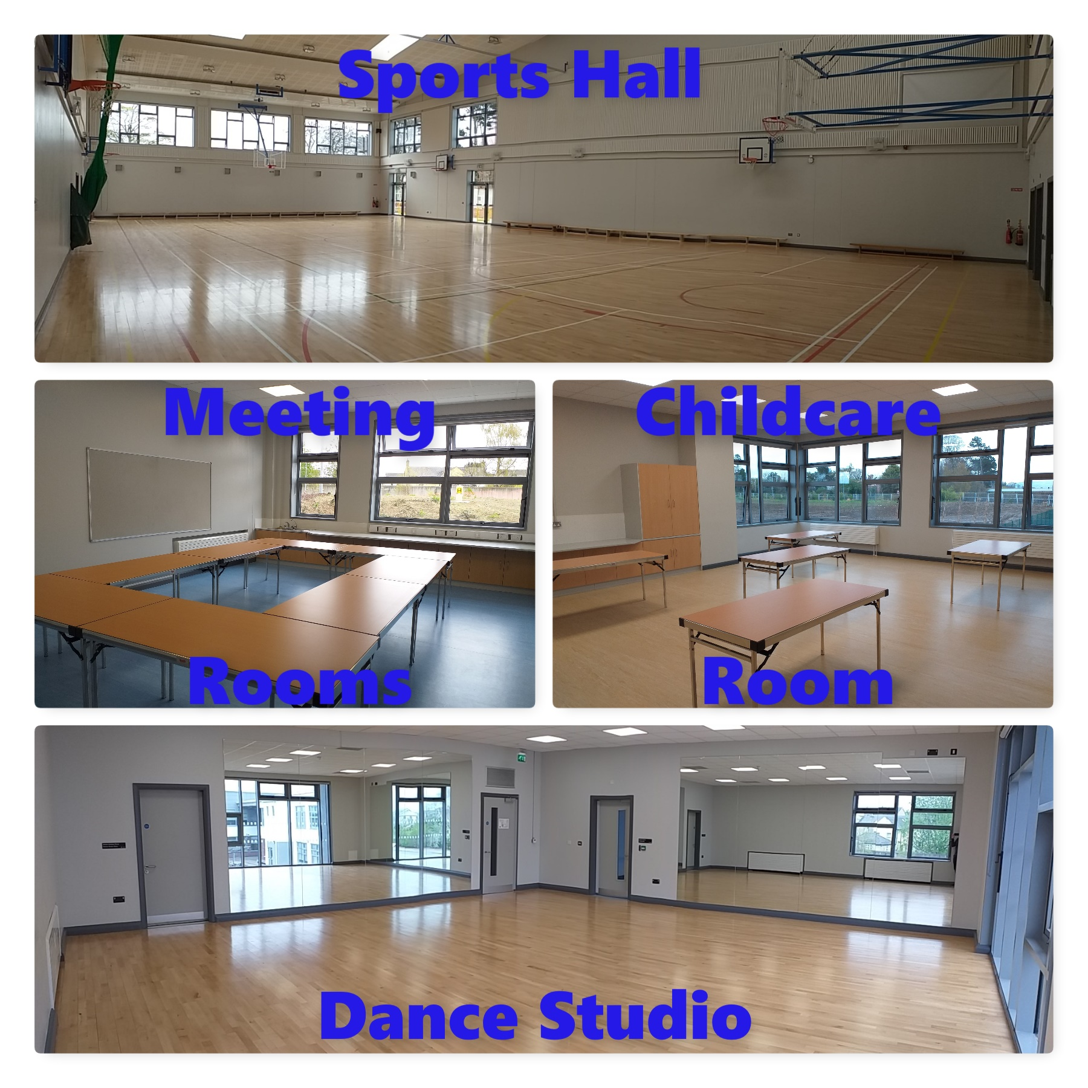
Facilities Include

For more information or to book
Email: luttrellstowncommunitycentre@gmail.com

